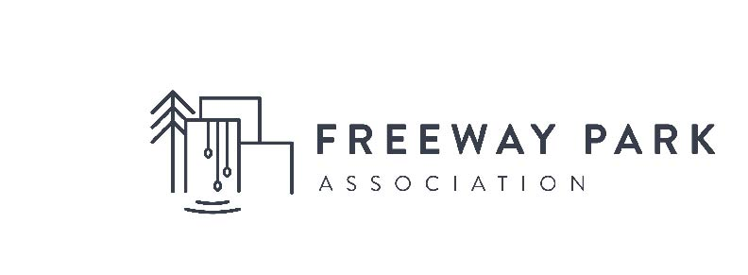
Summer Park Concierge Job Description:

The Freeway Park Association (FPA) has been a community steward to Freeway Park since 1993. In partnership with the Seattle Parks Department, FPA works to raise funds and provide creative, dynamic and accessible programming for Seattle’s largest and most iconic downtown park.

FPA seeks to hire two Seasonal Part-time Concierges from June-September 2019 to serve as ambassadors to Park visitors, set up daily park activations and, assist at special programs and events throughout the summer. Concierges will report to, and work collaboratively with a Lead Ambassador and Program Manager. (Schedule varies +/- 20 hours per week. $16/hr)
Responsibilities
- Serve as an on-the-ground liaison for vendors, permitted groups, sponsors, partners, volunteers and park patrons to ensure a positive park experience for everyone.
- Oversee and maintain Art installations in the park.
- Serve as Art Docent for our weekly Kite Painting Program.
- Help support community outreach alongside landscape architecture consultants managing the 2019 Capital Improvement Project.
- Daily set up of amenities (chairs, tables, signage bookcarts, PA etc) and activities in the park.
- Set-up and breakdown of special activations and programming; including staging, tents, signage, audio/video systems.
- Conduct daily counts of the men, women and children using the park throughout the day.
- Track number of event attendees, on-site media, any sponsor, vendor or public feedback.
- Document events and programming with pictures and reports.
- Ensure park areas are clean and free of debris prior to scheduled event/activation and before
departing the Park.
- Develop and maintain professional working relationships with local service providers, property
managers, merchants, Parks employees, and staff members
- Engage with vulnerable groups present in the parks in a humanitarian and compassionate manner while ensuring the safety of the Park.
- Be available as on-call back-up to Ambassador shifts.
- Other commensurate duties as assigned.
- Participate in programming and have fun!

Qualifications and Details:
- Interest in community building, urban public space activation and /or landscape architecture/urban design.
- Must be a true "people person," comfortable talking to small groups, individuals, and potential partners.
- Willingness and ability to work with people from a variety of racial, cultural and economic backgrounds, with various lifestyles, sexual orientations, and of all ages
- Ability to handle stressful situations, demonstrating diplomacy and tact under pressure.
- Self-motivated, energetic learner and leader with a good sense of humor.
- Strong interpersonal skills with the ability and willingness to work as part of a team.
- Knowledge of and comfortability working in Downtown Seattle
- A compassionate equity approach to social services
- Ability to troubleshoot and maintain company-owned equipment and amenities.
- Willing to work outside in all-weather conditions.
- Ability to move equipment weighing up to 50 pounds across park for events and programming
Additional Qualifications:
- Interest in Public Art
- Photography skills
+ Send Resumes with Letter of Interest and three Professional References to - alex@freewayparkassociation.org with Summer Park Concierge in the subject line.

